Custom Wordpress Plugin Spec

We need a plugin that will allow us to provide a youtube URL or youtube Playlist URL and store those as a post type ( Movie, Video, TV Show: Episode ) in wordpress.

High Level Outline Explainer:

* Allow user to submit youtube content for storage
  + By Youtube Video ( provide youtubeURL )
    - pull 1 time
  + By Youtube Playlist ( provide youtube Playlist URL )
    - pull every hour
    - should be able to enable/disable auto pull
    - show date time of last run
    - show last run status: successful or failed
* Choose where we want to place content
  + **Movie**
    - Choose Genre
    - Choose Tag ( optional )
    - When save of episode check if name matches any defined persons
      * If MATCH automatically associate that Person as Cast
  + **Video**
    - Choose Category
    - Choose Tag ( optional )
  + **TV Show** ( save video as episode, then associate to TV Show )
    - Choose Show
    - Choose Season
* When we hit save it should begin to save content

## 

## **How To Upload Movie**

All Movies: <https://wordpress-1149551-4406892.cloudwaysapps.com/wp-admin/edit.php?post_type=movie>

Add New Movie: <https://wordpress-1149551-4406892.cloudwaysapps.com/wp-admin/post-new.php?post_type=movie>

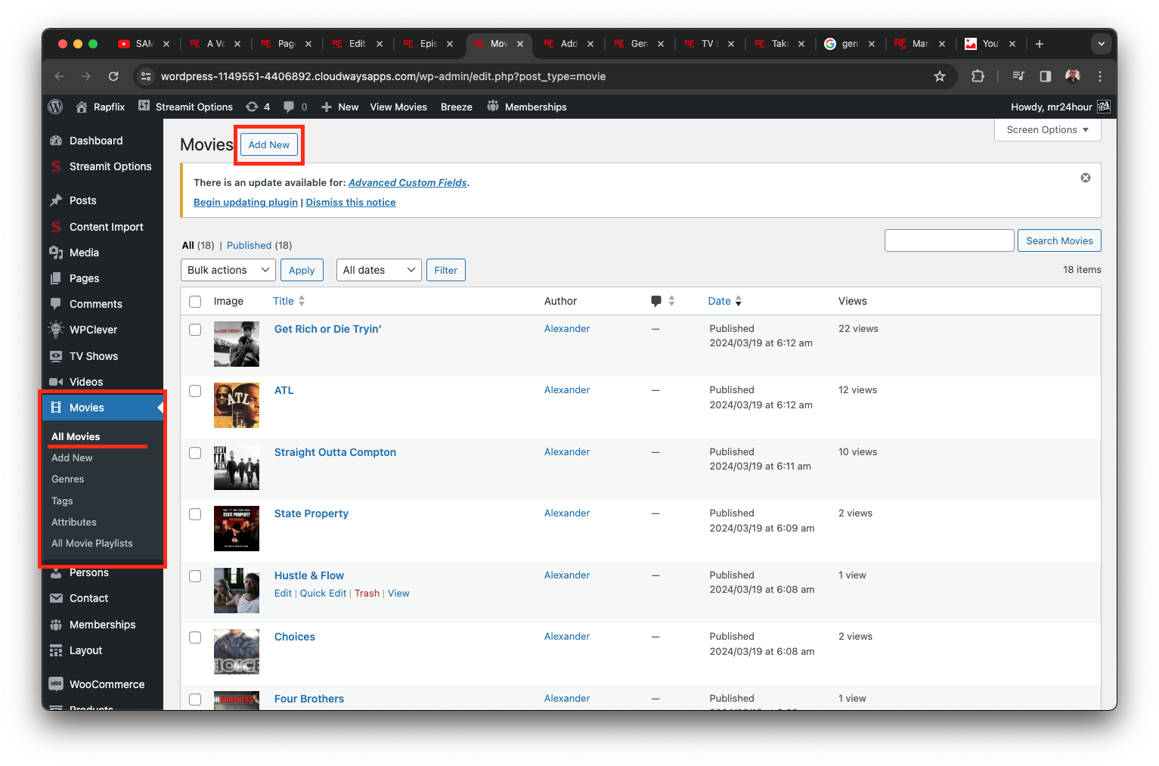

### Populate ONLY the following fields:

* Title ( title of youtube video )
* General:
  + Choose Movie Method: Movie URL
  + Movie Url ( youtube url )
  + Movie Release Date ( date posted to youtube )
* Movie short description ( youtube video description )
* Publish date ( current date of posting not youtube post date )
* Genres
* Movie Image ( youtube thumbnail )

## 

## **How To Upload Video**

All Videos: <https://wordpress-1149551-4406892.cloudwaysapps.com/wp-admin/edit.php?post_type=video>

Add New Video: <https://wordpress-1149551-4406892.cloudwaysapps.com/wp-admin/post-new.php?post_type=video>

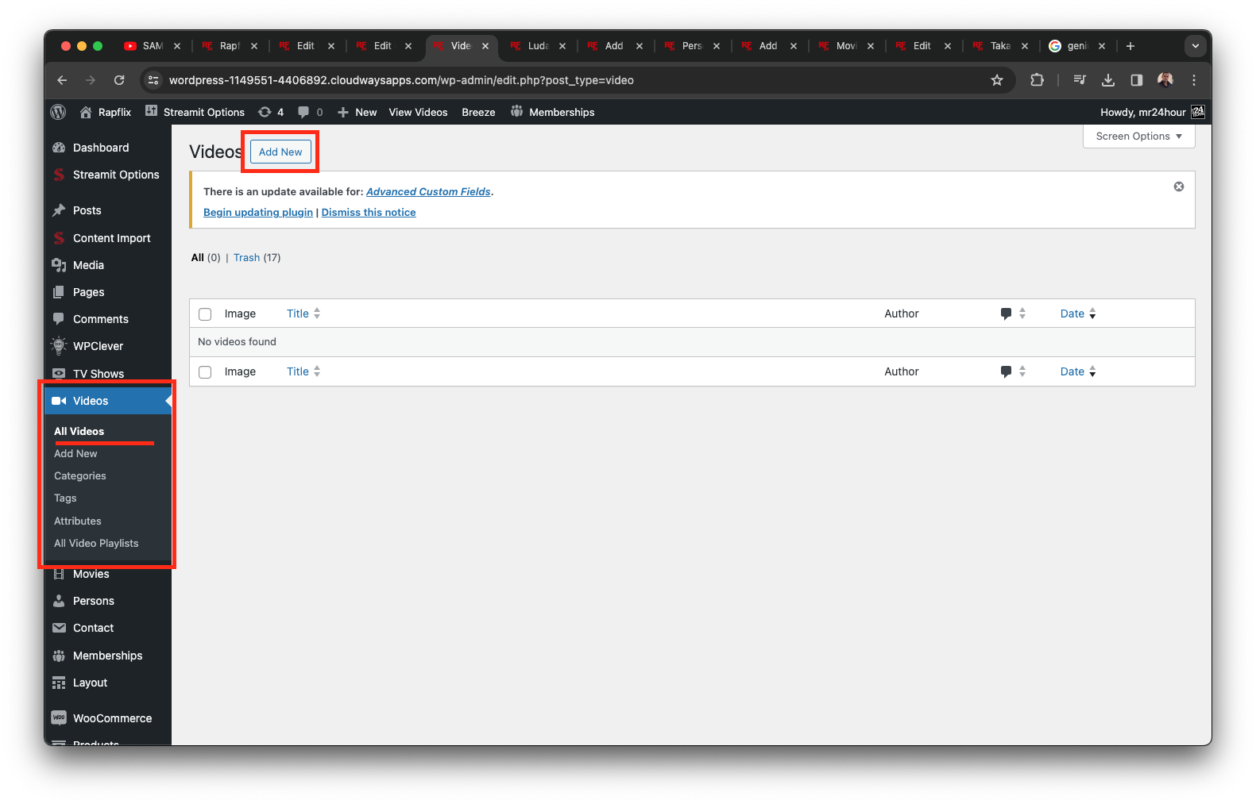

### Populate ONLY the following fields:

* Title ( title of youtube video )
* Video Time Duration
* Start View Counter ( randomly set between 567 - 1234 )
* General:
  + Choose Video Method: Video URL
  + Video Url ( youtube url )
* Video short description ( youtube video description )
* Publish date ( current date of posting not youtube post date )
* Video Image ( youtube thumbnail )

## **How To Upload Episode**

All Episodes: <https://wordpress-1149551-4406892.cloudwaysapps.com/wp-admin/edit.php?post_type=episode>

Add New Episode: <https://wordpress-1149551-4406892.cloudwaysapps.com/wp-admin/post-new.php?post_type=episode>

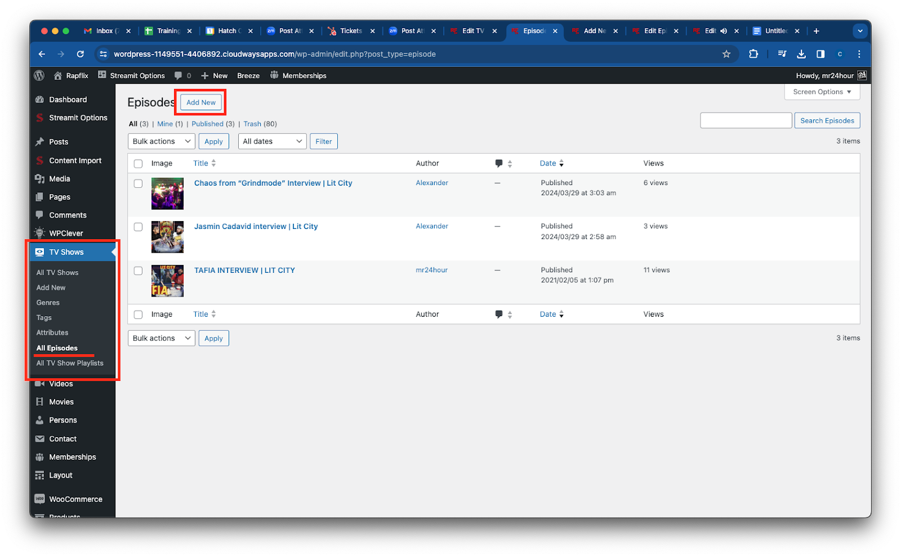

### Populate ONLY the following fields:

* Title ( title of youtube video )
* Start View Counter ( randomly set between 567 - 1234 )
* General:
  + Choose Episode Method: Episode URL
  + Episode Url ( youtube url )
  + Episode Release Date ( date posted to youtube )
* Episode short description ( youtube video description )
* Publish date ( current date of posting not youtube post date )
* Episode Image ( youtube thumbnail )

## **How To Edit a TV Show to Associate Episodes**

All TV Shows: <https://wordpress-1149551-4406892.cloudwaysapps.com/wp-admin/edit.php?post_type=tv_show>

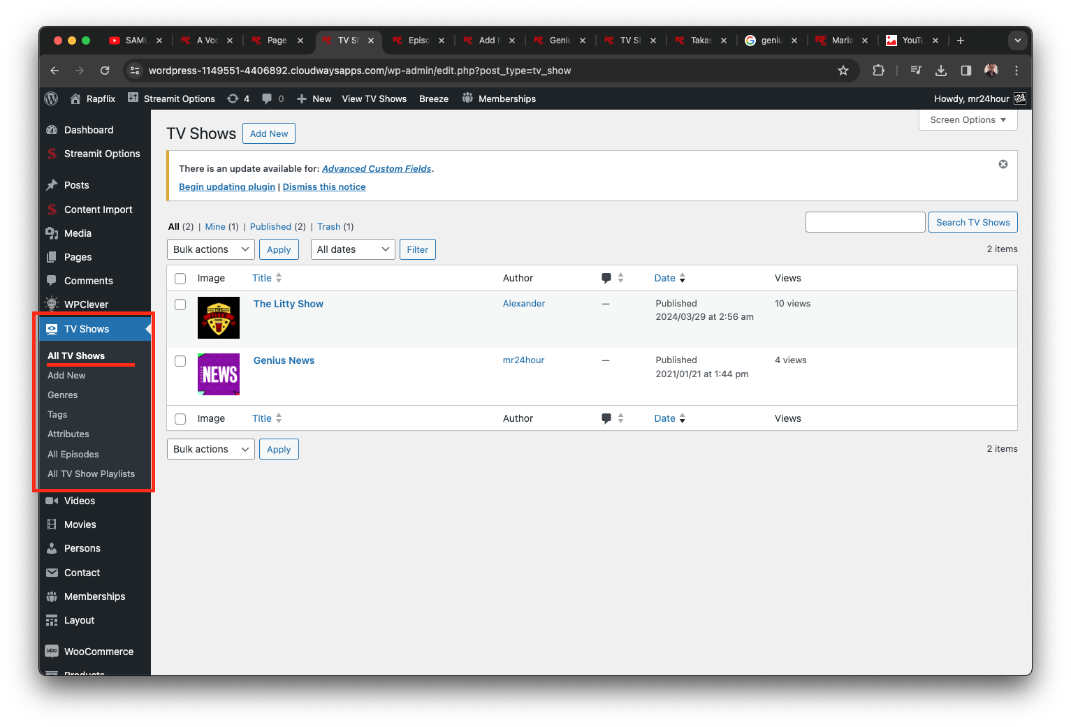

Edit TV Show Fill out ONLY the following fields:

* Seasons & Episodes:
  + Choose Season
    - Episode(s) ( associate uploaded episodes )\

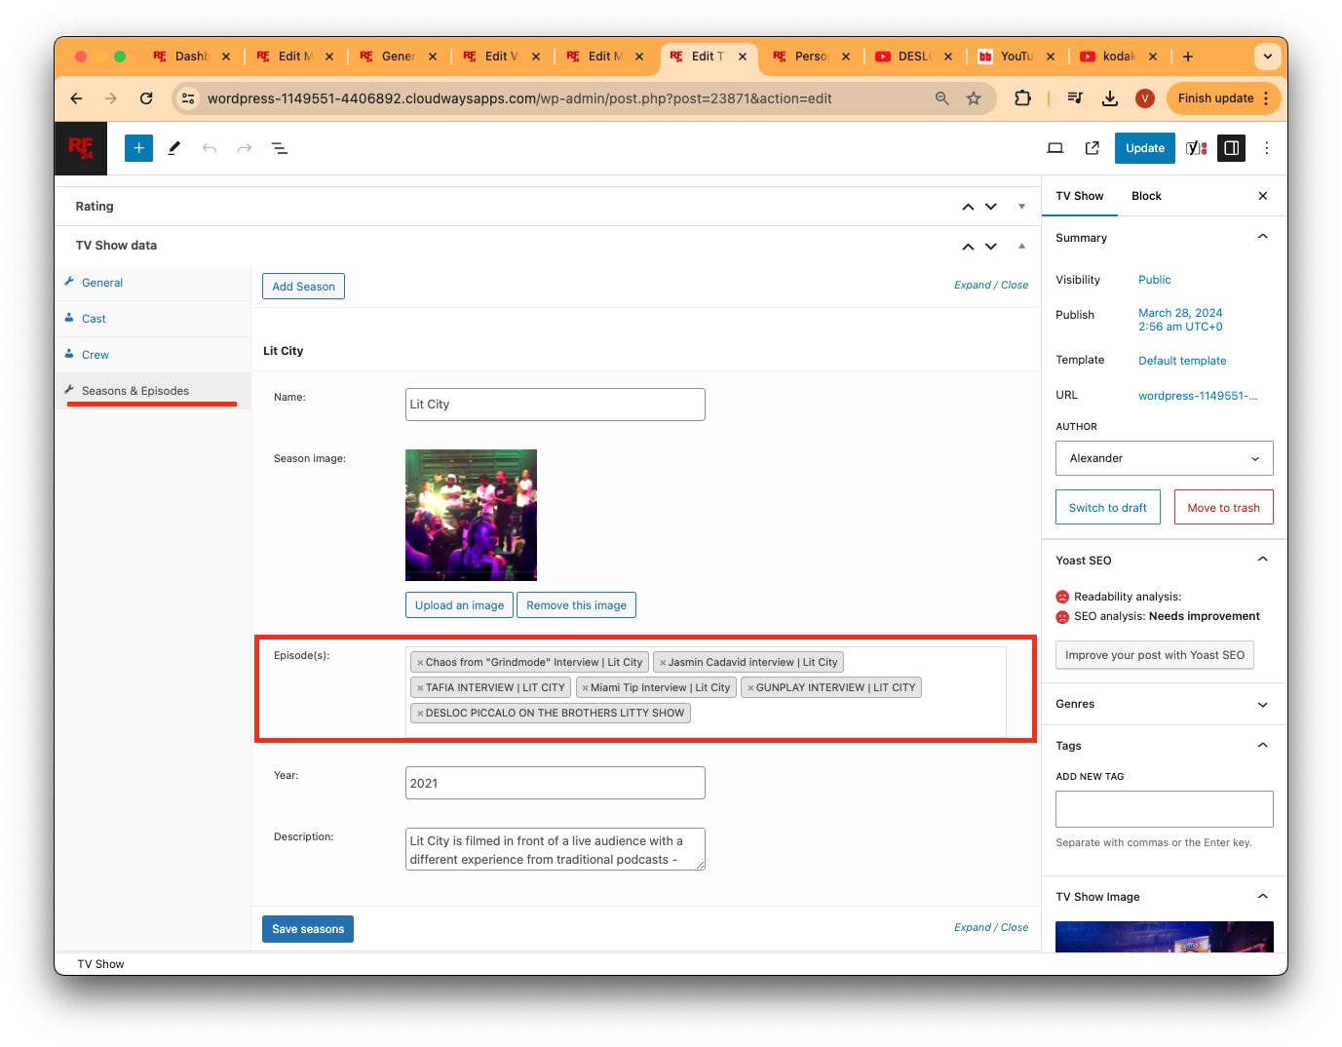

## **Persons Manager**

When adding movies, we want to associate related people as the cast of the movie. We need to edit Movie Data: Cast to add Related Cast Members to a movie. We should add anyone who matches the name of the movie.

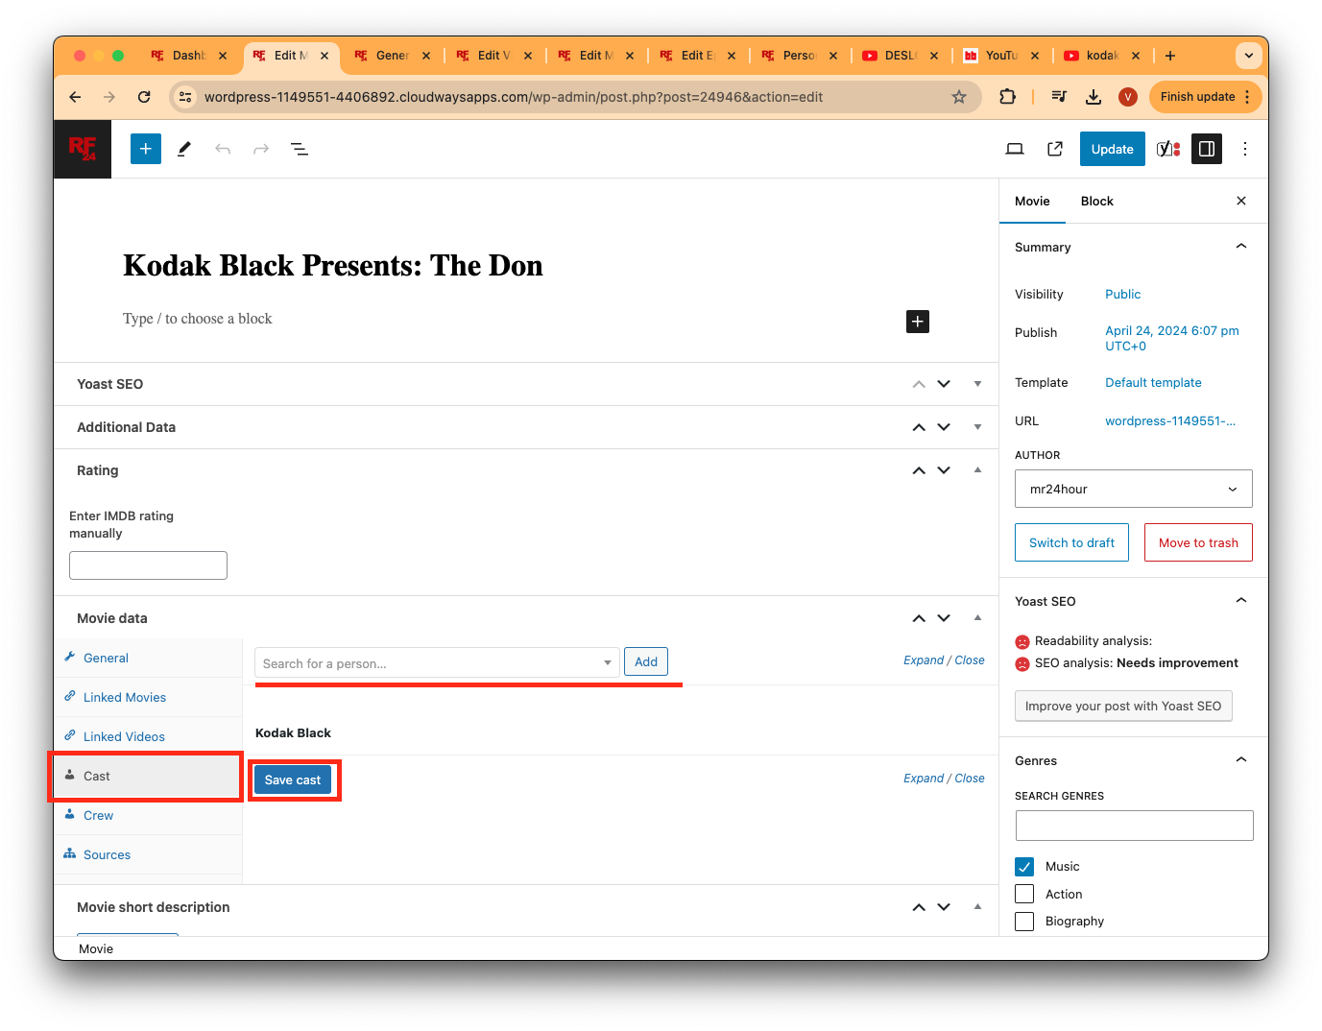

All Persons Manager: <https://wordpress-1149551-4406892.cloudwaysapps.com/wp-admin/edit.php?post_type=person>

